

In the name of God,

the merciful, the compassionate

HomeWork 8  
(Tracking, Disturbance and LQR)

By

*Reza Nopour*  
402126924

Advanced Automatic Control  
Mechanical Engineering Department  
Amirkabir University of Technology  
15 Jan. 24

# Problem 1 Description

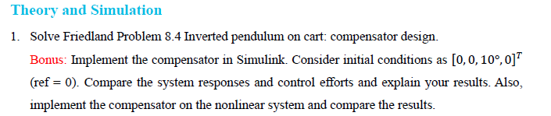

# Solution

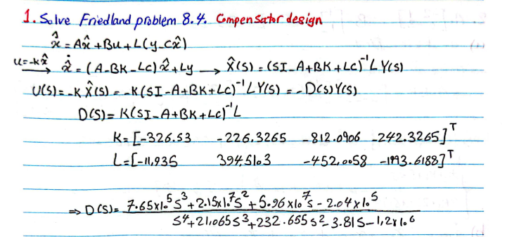

# Bonus

Systems are implemented in MATLAB Simulink and the results for both linear and nonlinear system is as follows,

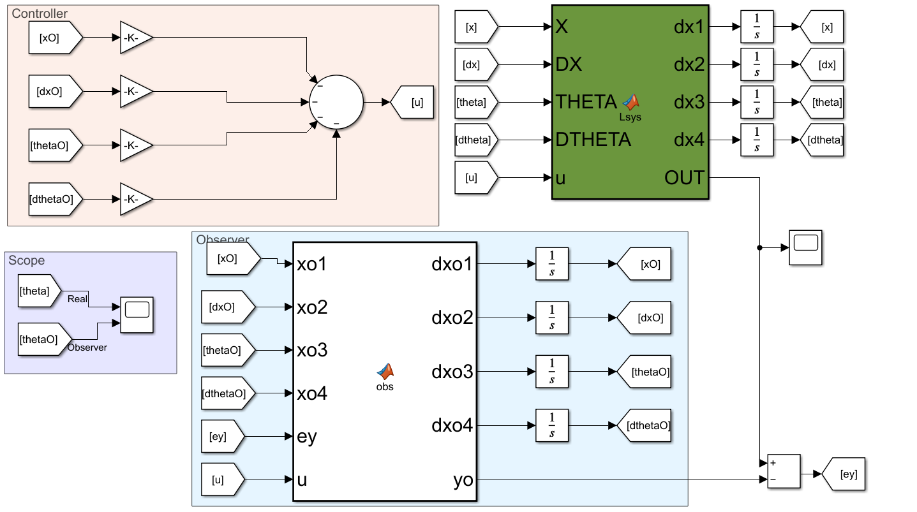

Figure 1 Linear system with compensator.

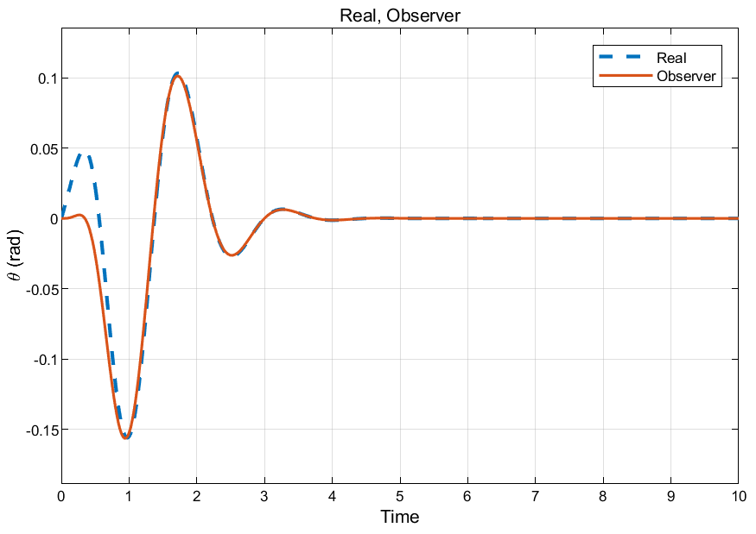

Figure Linear system result.

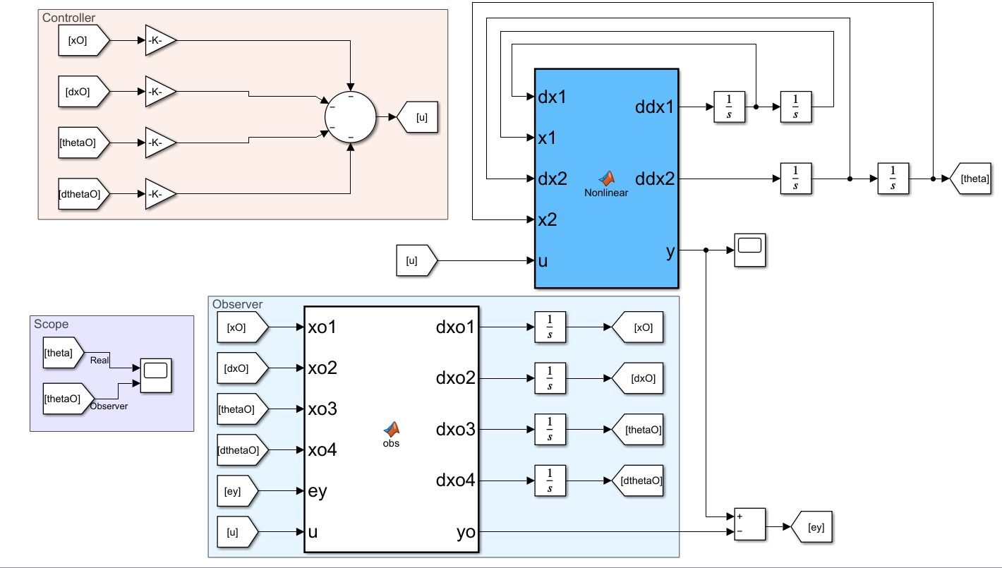

Figure Nonlinear system with compensator.

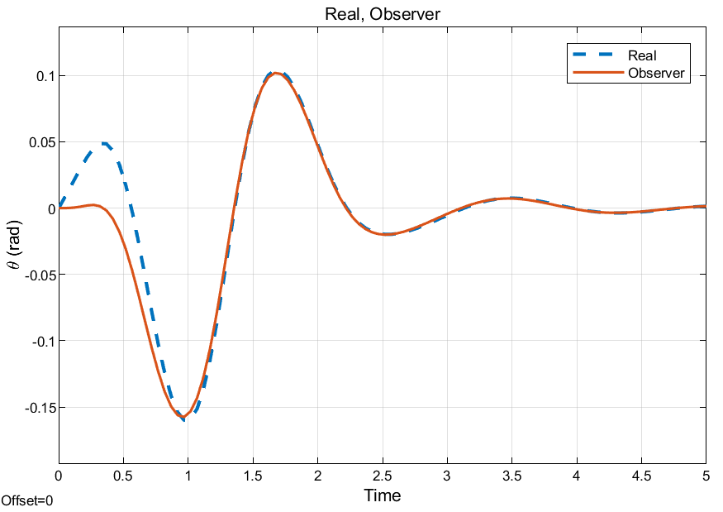

Figure Nonlinear system result.

# Problem 2 Description

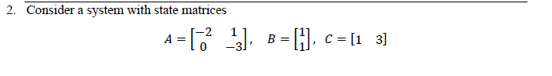

# Solution

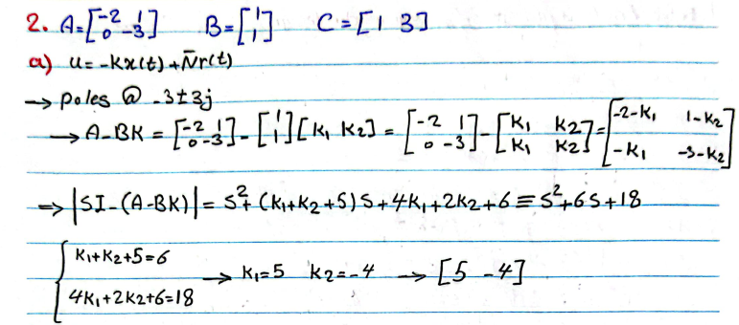

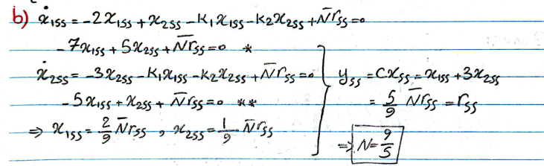

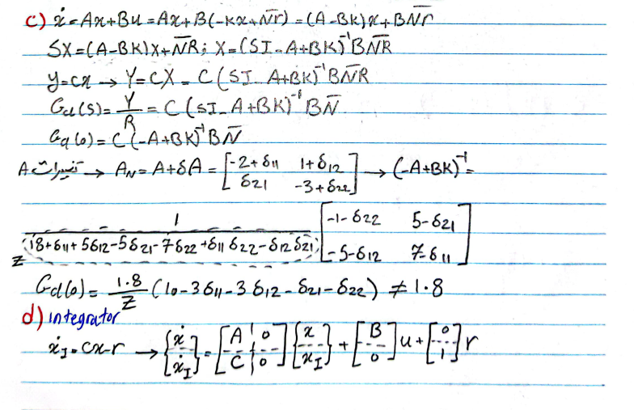

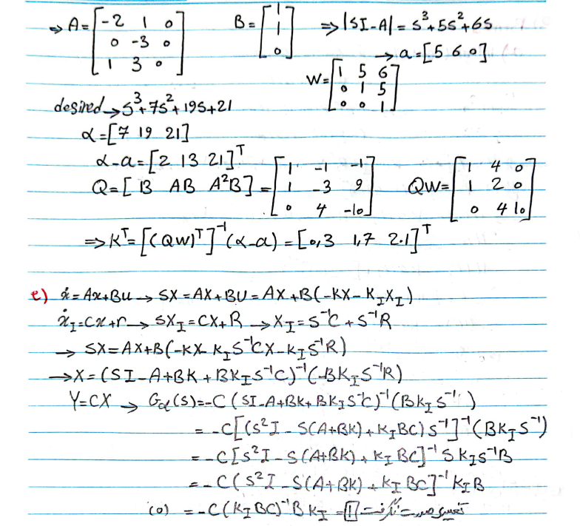

# Bonus

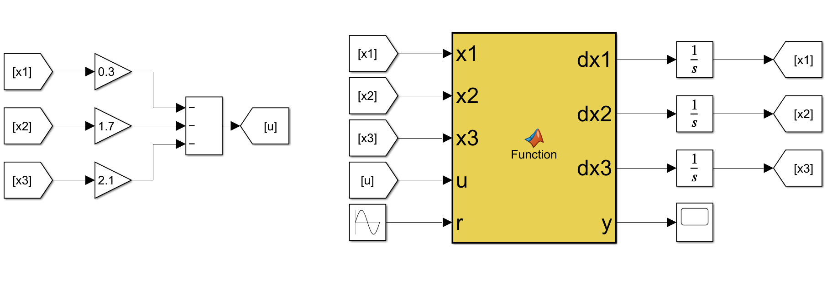

Figure system with sine wave as input.

Final response of the system follows the sine wave!

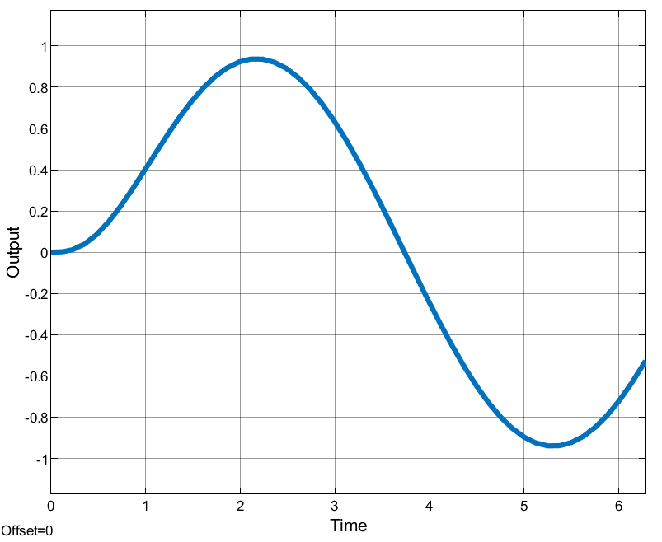

Figure system result with sine wave as input.

# Problem 3 Description (Bonus)

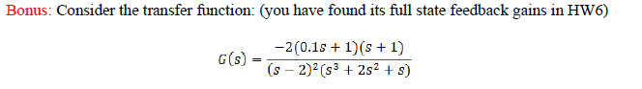

# Solution

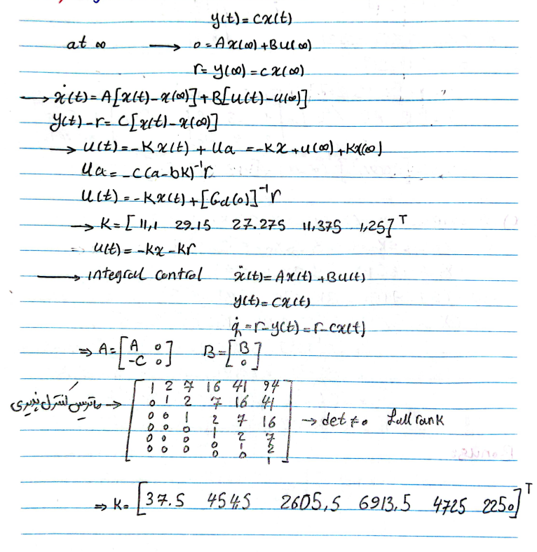

# Problem 4 Description



# Solution

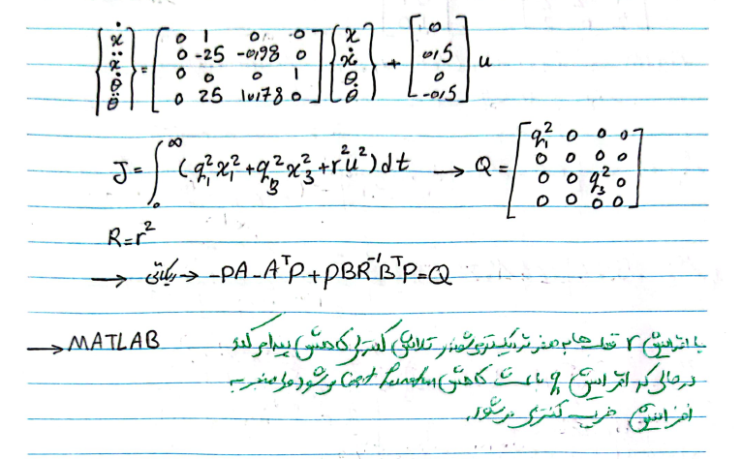

**

**

|  |
| --- |
| clc  clear  close all  M = 1;  m = 0.1;  l = 1;  g = 9.8;  k = 1;  R = 100;  r = 0.02;  A = [0 1 0 0;...  0 -k^2/(M*r^2*R) -m*g/M 0;...  0 0 0 1;...  0 k^2/(M*r^2*R*l) (M+m)*g/(M*l) 0];  B = [0;k/(M*R*r);0;-k/(M*R*r*l)];  q1 = 100;  q3 = 3000;  Q = [q1 0 0 0;0 0 0 0;0 0 q3 0;0 0 0 0];  R = 0.001:0.1:50;  for i = 1:numel(R)  K(i,:) = lqr(A,B,Q,R(i));  Ac = A-B*K(i,:);  landa(:,i) = real(eig(Ac));  end  figure(1)  subplot(4,1,1)  plot(R,K(:,1),'linewidth',1.6)  grid on  grid minor  xlabel('$r^{2}$','Interpreter','latex')  ylabel('$K_{1}$','Interpreter','latex')  set(gca,'FontSize',12)  set(gca,'fontname','Times New Roman')  subplot(4,1,2)  plot(R,K(:,2),'linewidth',1.6)  grid on  grid minor  xlabel('$r^{2}$','Interpreter','latex')  ylabel('$K_{2}$','Interpreter','latex')  set(gca,'FontSize',12)  set(gca,'fontname','Times New Roman')  subplot(4,1,3)  plot(R,K(:,3),'linewidth',1.6)  grid on  grid minor  xlabel('$r^{2}$','Interpreter','latex')  ylabel('$K_{3}$','Interpreter','latex')  set(gca,'FontSize',12)  set(gca,'fontname','Times New Roman')  subplot(4,1,4)  plot(R,K(:,4),'linewidth',1.6)  grid on  grid minor  xlabel('$r^{2}$','Interpreter','latex')  ylabel('$K_{4}$','Interpreter','latex')  set(gca,'FontSize',12)  set(gca,'fontname','Times New Roman')  figure(2)  subplot(4,1,1)  plot(R,landa(1,:),'linewidth',1.6)  grid on  grid minor  xlabel('$r^{2}$','Interpreter','latex')  ylabel('$\lambda_{1}$','Interpreter','latex')  set(gca,'FontSize',12)  set(gca,'fontname','Times New Roman')  subplot(4,1,2)  plot(R,landa(2,:),'linewidth',1.6)  grid on  grid minor  xlabel('$r^{2}$','Interpreter','latex')  ylabel('$\lambda_{2}$','Interpreter','latex')  set(gca,'FontSize',12)  set(gca,'fontname','Times New Roman')  subplot(4,1,3)  plot(R,landa(3,:),'linewidth',1.6)  grid on  grid minor  xlabel('$r^{2}$','Interpreter','latex')  ylabel('$\lambda_{3}$','Interpreter','latex')  set(gca,'FontSize',12)  set(gca,'fontname','Times New Roman')  subplot(4,1,4)  plot(R,landa(4,:),'linewidth',1.6)  grid on  grid minor  xlabel('$r^{2}$','Interpreter','latex')  ylabel('$\lambda_{4}$','Interpreter','latex')  set(gca,'FontSize',12)  set(gca,'fontname','Times New Roman') |

# Problem 5 Description

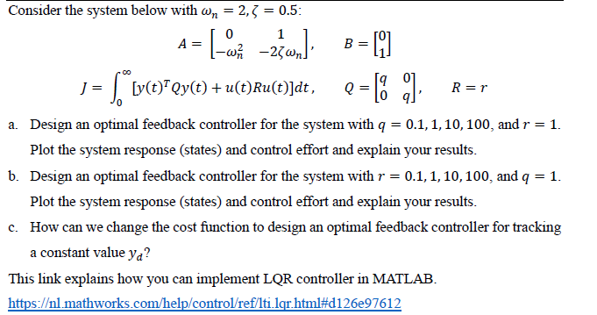

# Solution

1. Increasing $q$ value, results in increasing the control effort, as placing the poles far from the origin.







1. Increasing $r$ value, results in decreasing the control effort, as placing the poles near the origin.







1. For feedback control, usually an integral controller would be added by increasing the states of the system, consequently, an increase in $Q$, matrix is inevitable! $Q$ can be diagonally $1/\max{(states)}$.

# Problem 6 Description

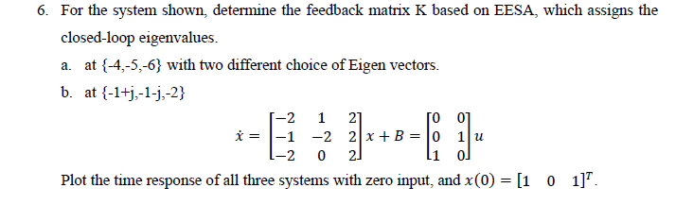

# Solution

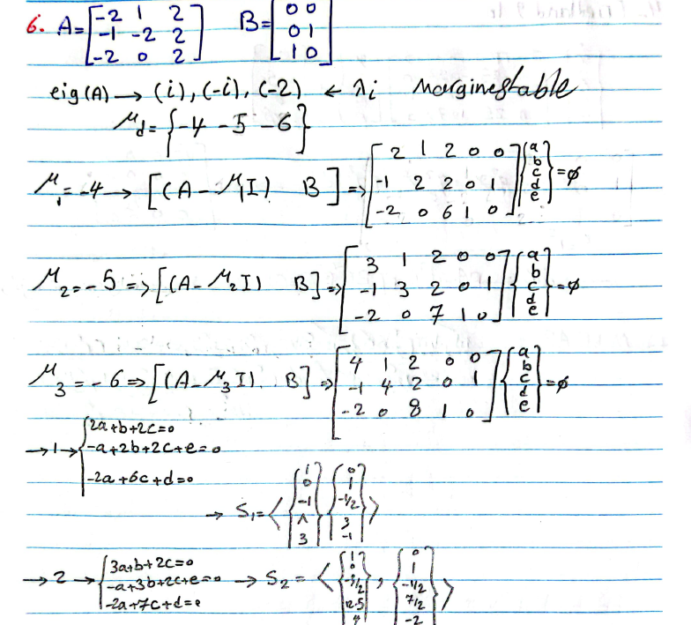

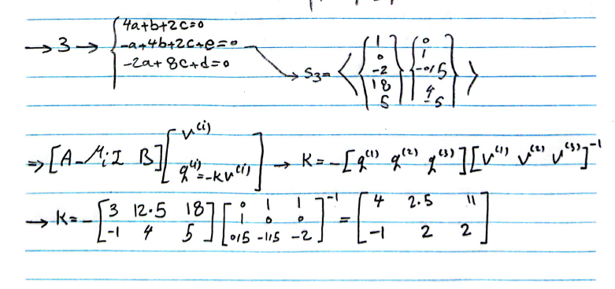

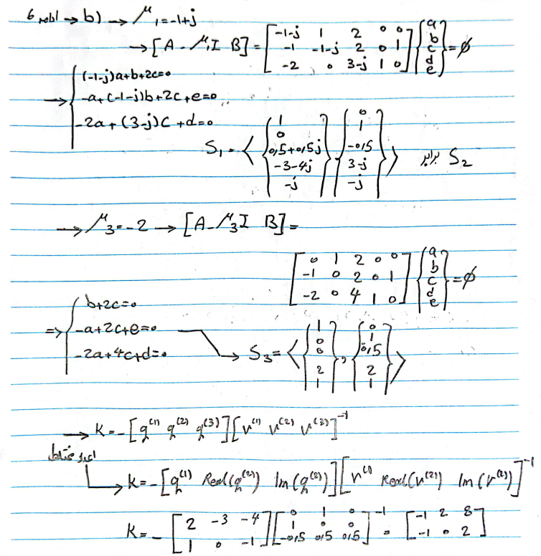

با دستور null متلب نیز بررسی شد، که جوابها متفاوت بود :_)

|  |
| --- |
| clc  clear  A=[-2 1 2;-1 -2 2;-2 0 2];  B=[0 0;0 1;1 0];  m1=[-4 -5 -6].';  A1=[A-m1(1)*eye(3) B];  A1=null(A1)  q1=real(A1(4:end,1))  v1=real(A1(1:3,1))  A2=[A-m1(2)*eye(3) B];  A2=null(A2)  q2=real(A2(4:end,2))  v2=real(A2(1:3,2))  A3=[A-m1(3)*eye(3) B];  A3=null(A3)  q3=real(A3(4:end,1))  v3=real(A3(1:3,1))  k=-[q1 q2 q3]*[v1 v2 v3]^-1  place(A,B,m1)  %% 2  A=[-2 1 2;-1 -2 2;-2 0 2];  B=[0 0;0 1;1 0];  m1=[-1+1i;-1-1i;-2].';  A1=[A-m1(1)*eye(3) B];  A1=null(A1)  q1=real(A1(4:end,1))  v1=real(A1(1:3,1))  A2=[A-m1(2)*eye(3) B];  A2=null(A2)  q2=imag(A1(4:end,1))  v2=imag(A1(1:3,1))  A3=[A-m1(3)*eye(3) B];  A3=null(A3)  q3=real(A3(4:end,2))  v3=real(A3(1:3,2))  k=-[q1 q2 q3]*inv([v1 v2 v3])  place(A,B,m1) |







در حالت a، که قطبها دورتر از مرکز هستند، جواب زودتر به حالت پایدار خودش بازمیگردد، زیرا تلاش کنترلی آن، همانطور که نشان داده شده است، بیشتر خواهد بود.

در حالت real به دلیل وجود قطب در روی محور موهومی، جواب به صورت marginally stable هست.



به دلیل وجود دو سطر (دو ضریب کنترلی)، دو مقدار برای هر قسمت محاسبه شده است.